January 20, 2023
Week of January 23-27
Clothing Drive for Schools in Need

MONDAY 23rd

TUESDAY 24th
Boys’ basketball afterschool
LUNAR New Year Celebrations – thank you parents for hosting!
Spirit Day: Red & Gold

WEDNESDAY 25th
Early Dismissal 1:30
Robbie Burns Day – Mad about Plaid spirit day
Boys’ basketball HOME game 2:45

THURSDAY 26th
Boys’ basketball practice lunch
Girls’ basketball HOME game afterschool
Hot Lunch

FRIDAY Dec 27th
Spirit Day – Beach wear

We Share The Air – Thank you for helping us contribute to a 'SCENT SAFE' environment by refraining from wearing scented products when visiting the school.

Clothing Drive for Sister Schools
One of our sister schools in the North is collecting donations for their after-school clothing drive where students and families can pick up free clothing after school at a Clothing Market. They are in need of more gently used clothing and shoes of all sizes to keep their market going. If you have items to donate please bring them to the front of the school (or have students bring down to the office) Jan 23-27th. Thank You!

If you pick up/drop-off your child in front of the school we ask that you please drive very slowly. Although school zones have a maximum of 30km before and after school there are many students that cross the street and the view is blocked by cars waiting in the line for the drive through area or parked on the street. We also see many cars driving too fast through the drop-off/pick-up area. Please remember that we have many small children exiting and entering cars and crossing the street. It is very congested in front of our school and we ask all drivers to drive slowly (much slower than the 30km maximum) and with extra caution before/after school. Also, please do not make U-turns in front of the school and respect supervisors outside trying to ensure the safety of everyone.

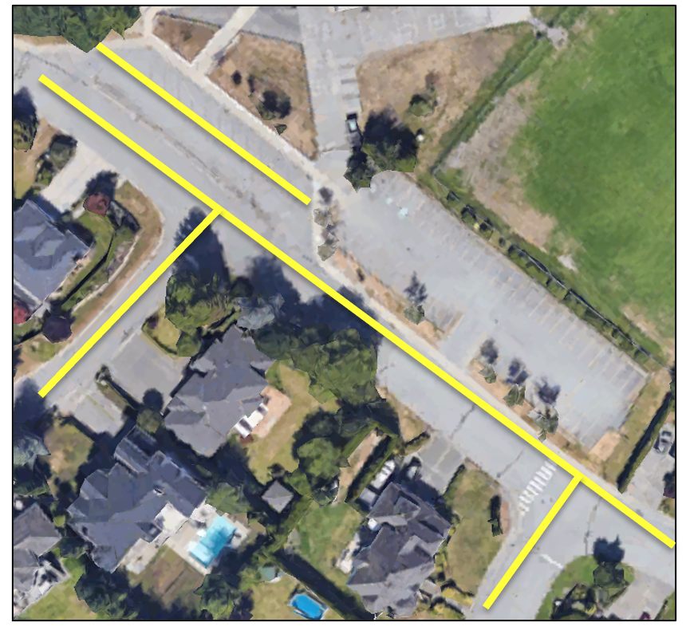
Areas in yellow should be driven very slowly (much below 30 km) during pick-up and drop-off times. There are many students and younger siblings walking and visibility is often limited by the number of cars parked & waiting.

Thank you for your care & consideration.

Upcoming Calendar Dates
Jan 24 Lunar New Year Celebration
Jan 25 Early Dismissal 1:30 pm
Mad about Plaid Spirit Day (new)
Jan 27 Spirit Day – Beach Day
Hot Lunch – chopped leaf
Feb 9 PAC Meeting 9am library
Feb 10 Hot Lunch - subway
Feb. 14 Valentine’s Day spirit day (red, white, pink, purple)
Feb 17 Kernels fundraiser (pick up after school)
Feb. 20 Family Day (School Closed)
Feb 22 Anti-Bullying/Pink Shirt Day (wear pink)
Feb. 24 Non-Instructional Day
March 9 Term 2 Reports Home / Last Day of School
Neurodiversity Awareness Assembly
March 13-24 Spring Break and School Closure Days

