Applicant’s Name:

Name of Reference:

Position / Employer:
U

Thank you for providing your observations of this applicant’s leadership work and your assessment of their potential in the above position. The Surrey School District will ensure that the information you provide is kept confidential, in accordance with the Freedom of Information and Protection of Privacy Act.
In what capacity have you known the applicant?

How long have you known the applicant?
- Using the Leadership Competencies below, please select 3 phrases that you feel best describe the candidate and relates to the position of Director or Director of Instruction, Racial Equity.

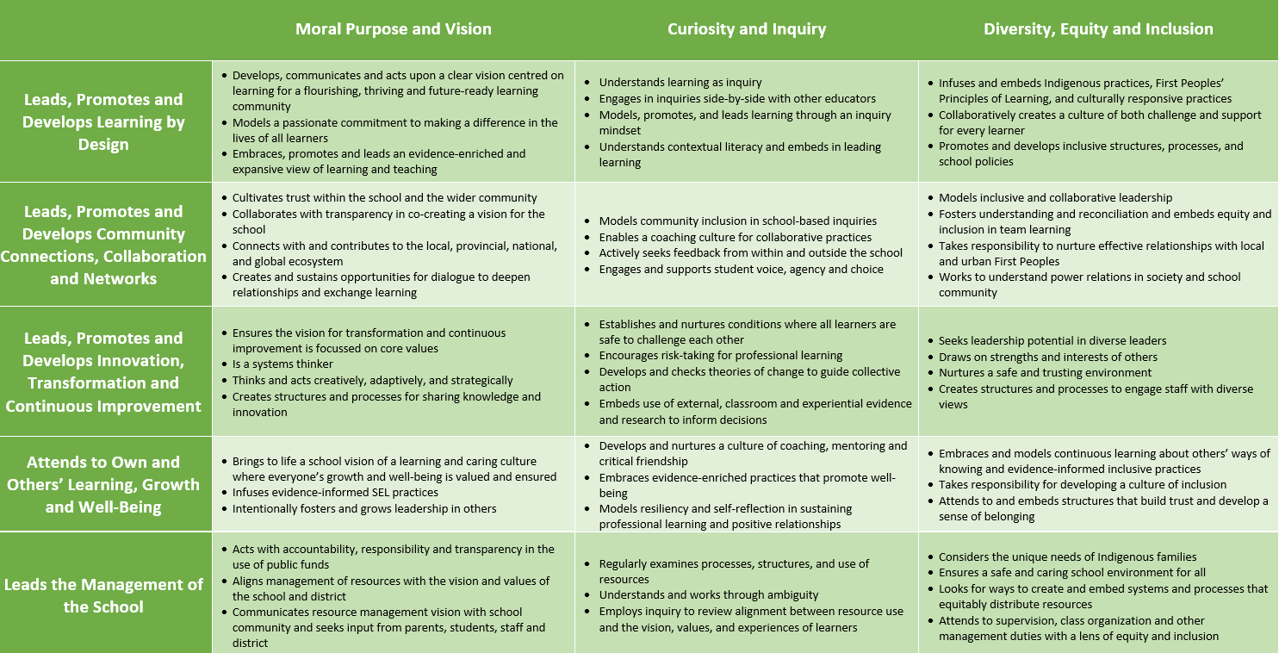

 | Competency | Why selected? | Provide your best example from their work that shows how they demonstrated this  competency.
a.
b.
c.

- From the above competency chart please name two areas for professional growth, specifically related to this position, for the candidate. Please explain why you chose those areas. If you are unable to choose two areas for growth, please identify why.

- Provide an example in which the candidate built a trusting relationship in the face of adversity.

- Describe an example of when the candidate has demonstrated learning leadership in relation to Racial Equity.

Revised Sept 2022
Page 3 of 4

- Comment on the candidate’s collaborative skills in working with colleagues, school or organizational leaders, students and families.

6. Would you like to be led by this person? | Yes |  | No
7. Would you recommend this individual for the position sought? | Yes |  | No
8. Would you hire or rehire this individual for this position in your district? | Yes |  | No
9. Are we free to discuss your comments with the applicant? | Yes |  | No
10. Optional: please provide any other information you believe we should know about the candidate.

Signature of Reference: Date:
Email Address: Telephone:
please indicate home, office, cell

Please send your completed document to supr-office@surreyschools.ca

Page 4 of 4

