Grade 7 Parents & Students
Please join us………

Wednesday, March 11, 2020
For an Informational Evening Regarding Grade 8 at Guildford Park Secondary

6:30 PM Guided Tours of School Building (optional)
7:00-8:00 PM Presentation in the Plaza (Cafeteria)

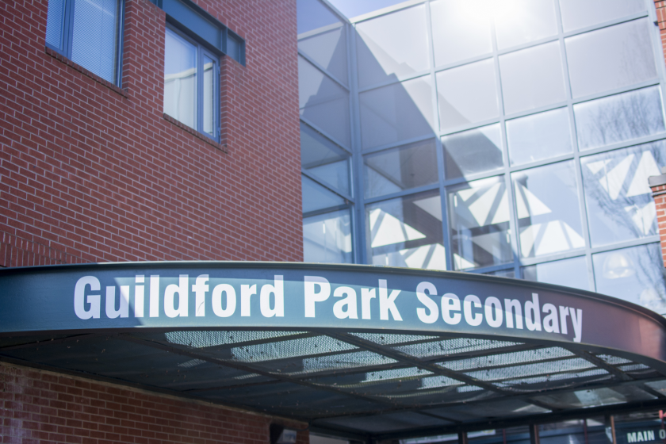

“EVERYONE MATTERS!”

